



**CIS 326: IT**

**Infrastructure Management**

Group 7





**Group Members**

**Group 7**

|  |  |
| --- | --- |
| **1. Hassan Alzourei** | **2220004853** |
| **2- Haider Aljarrash** | **2220002168** |
| **3- Abdullah Alotibie** | **2210002017** |
| **4- Mohammed Aldarwish** | **2200001018** |

* 1. **Introduction**



## IAU

Background

A fundamental computer network denotes the successful interconnection of two or more devices, facilitated through either wired or wireless mediums. Networks play a pivotal role in facilitating various forms of communication among members and between different entities. Envision a world devoid of communicative networks, life would seem incomplete. Computer networking is enhancing efficiency and enabling seamless file-sharing. Networks typically comprise essential devices like routers, responsible for managing data packets by receiving, analyzing, and forwarding them. Another crucial component is the switch, which consolidates incoming packets and directs them through specified ports to their intended destinations. Additionally, there are end devices such as servers, PCs, laptops, printers, and IP phone devices, all collectively classified as peripherals.

* 1. **Introduction**



## IAU

Objective

The network topology within the context of the "Packet Tracer" simulates a communicative network designed for the Coffee Shop Network. Through this network infrastructure, managers and employees can seamlessly access and share data without constraints. Furthermore, the network facilitates effective interactions between employees and customers. This report seeks to establish World Area Networks (WANs) while connecting branches with each other. The scope of data exchange within five categories: management unit, customer service, and three branches.

### Topology Requirements

**Our topology includes the following tools:**

|  |  |
| --- | --- |
| **Assist** | **Quantity** |
| Laptop | **7** |
| printer | **2** |
| Access point | **7** |
| PC | **18** |
| Switches | **10** |
| Routers | **4** |
| Serial cables | **3** |
| Straight-through cables | **30** |
| Cross-over cables | **15** |
| Telephone | **2** |
| Server | **3** |
| Wireless LAN Controller | **3** |
| Wireless | **13** |
|  | |

### Set up the Topology

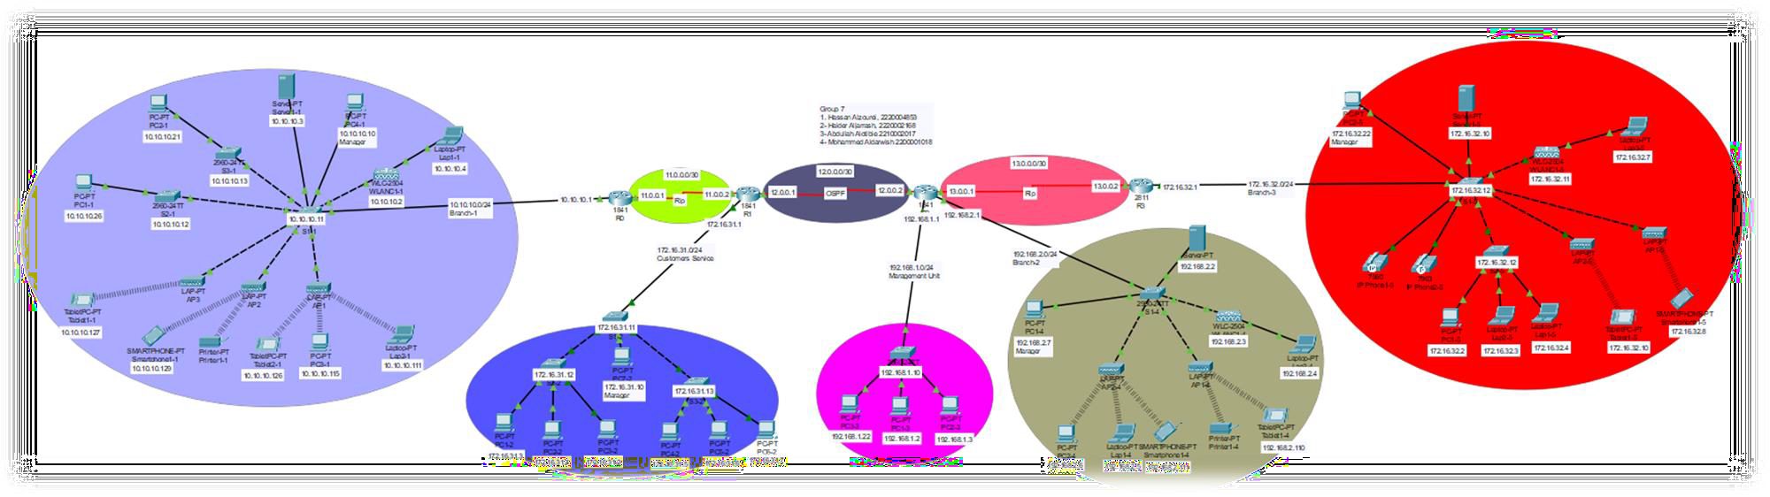**BRANCH-1 CUSTOMER SERVICE MANAGEMENT UNIT BRANCH-2 BRANCH-3**

* 1. **The Addressing Table**

|  |  |  |  |  |
| --- | --- | --- | --- | --- |
| **Device** | **Interface** | **IP Address** | **Subnet Mask** | **Default Gateway** |
| R0 | Fa0/0 | 10.10.10.1 | 255.255.255.0 | **-** |
| R0 | Se0/0/0 | 11.0.0.1 | 255.255.255.252 | **-** |
| R1 | Se0/0/0 | 11.0.0.2 | 255.255.255.252 | **-** |
| R1 | Se0/0/1 | 12.0.0.1 | 255.255.255.252 | **-** |
| R2 | Se0/0/1 | 12.0.0.2 | 255.255.255.252 | **-** |
| R2 | Se0/0/0 | 13.0.0.1 | 255.255.255.252 | **-** |
| R3 | Se0/0/0 | 13.0.0.2 | 255.255.255.252 | **-** |
| R3 | Fa0/0 | 172.16.32.1 | 255.255.255.0 | **-** |
| PC1-1 | Fa0 | 10.10.10.26 | 255.255.255.0 | **10.10.10.1** |
| PC2-1 | Fa0 | 10.10.10.21 | 255.255.255.0 | **10.10.10.1** |
| PC3-1 | Wireless | 10.10.10.115 | 255.255.255.0 | **10.10.10.1** |
| PC4-1 | Fa0 | 10.10.10.10 | 255.255.255.0 | **10.10.10.1** |
| PC1-2 | Fa0 | 172.16.31.3 | 255.255.255.0 | **172.16.31.1** |
| PC2-2 | Fa0 | 172.16.31.4 | 255.255.255.0 | **172.16.31.1** |
| PC3-2 | Fa0 | 172.16.31.2 | 255.255.255.0 | **172.16.31.1** |
| PC4-2 | Fa0 | 172.16.31.5 | 255.255.255.0 | **172.16.31.1** |
| PC5-2 | Fa0 | 172.16.31.6 | 255.255.255.0 | **172.16.31.1** |
| PC6-2 | Fa0 | 172.16.31.7 | 255.255.255.0 | **172.16.31.1** |
| PC7-2 | Fa0 | 172.16.31.10 | 255.255.255.0 | **172.16.31.1** |
| PC1-3 | Fa0 | 192.168.1.2 | 255.255.255.0 | **192.168.1.1** |
| PC2-3 | Fa0 | 192.168.1.3 | 255.255.255.0 | **192.168.1.1** |
| PC3-3 | Fa0 | 192.168.1.22 | 255.255.255.0 | **192.168.1.1** |
| PC1-4 | Fa0 | 192.168.2.7 | 255.255.255.0 | **192.168.2.1** |
| PC2-4 | Wireless | 192.168.2.6 | 255.255.255.0 | **192.168.2.1** |
| PC1-5 | Fa0 | 172.16.32.2 | 255.255.255.0 | **172.16.32.1** |
| PC2-5 | Fa0 | 172.16.32.22 | 255.255.255.0 | **172.16.32.1** |

* 1. **The Addressing Table**

|  |  |  |  |  |
| --- | --- | --- | --- | --- |
| **Device** | **Interface** | **IP Address** | **Subnet Mask** | **Default Gateway** |
| Laptop1-1 | Fa0 | 10.10.10.4 | 255.255.255.0 | **10.10.10.1** |
| Laptop2-1 | Wireless | 10.10.10.111 | 255.255.255.0 | **10.10.10.1** |
| Laptop1-4 | Wireless | 192.16.2.5 | 255.255.255.0 | **192.16.2.1** |
| Laptop2-4 | Fa0 | 192.16.2.4 | 255.255.255.0 | **192.16.2.1** |
| Laptop1-5 | Fa0 | 172.16.32.4 | 255.255.255.0 | **172.16.32.1** |
| Laptop2-5 | Fa0 | 172.16.32.3 | 255.255.255.0 | **172.16.32.1** |
| Laptop3-5 | Fa0 | 172.16.32.7 | 255.255.255.0 | **172.16.32.1** |
| R2 | Fa0/0 | 192.16.1.1 | 255.255.255.0 | **-** |
| R2 | Fa0/1 | 172.16.31.1 | 255.255.255.0 | **-** |
| R1 | Fa0/0 | 10.10.10.21 | 255.255.255.0 | **-** |
| Printer1-1 | Wireless | DHCP | 255.255.255.0 | **10.10.10.1** |
| Printer1-4 | Wireless | DHCP | 255.255.255.0 | **192.16.2.1** |
| Tablet1-1 | Wireless | 10.10.10.127 | 255.255.255.0 | **10.10.10.1** |
| Tablet2-1 | Wireless | 10.10.10.126 | 255.255.255.0 | **10.10.10.1** |
| Tablet1-4 | Wireless | 192.168.2.110 | 255.255.255.0 | **192.168.2.1** |
| Tablet1-5 | Wireless | 172.16.32.10 | 255.255.255.0 | **172.16.32.1** |
| SmartPhone1-1 | Wireless | 10.10.10.129 | 255.255.255.0 | **10.10.10.1** |
| SmartPhone1-4 | Wireless | 192.168.2.111 | 255.255.255.0 | **192.168.2.1** |
| SmartPhone1-5 | Wireless | 172.16.32.8 | 255.255.255.0 | **172.16.32.1** |
| R0 | Fa0/0.100 | 10.10.10.1 | 255.255.255.0 | **-** |
| R1 | Fa0/0.100 | 172.16.31.1 | 255.255.255.0 | **-** |
| R2 | Fa0/0.100 | 192.168.1.1 | 255.255.255.0 | **-** |
| R2 | Fa0/1.100 | 192.168.2.1 | 255.255.255.0 | **-** |
| R3 | Fa0/0.100 | 172.16.32.1 | 255.255.255.0 | **-** |
| WLANC1-1 | G0/1 | 10.10.10.2 | 255.255.255.0 | **10.10.10.1** |
| WLANC1-4 | G0/1 | 192.168.2.3 | 255.255.255.0 | **192.168.2.1** |

* 1. **The Addressing Table**

|  |  |  |  |  |
| --- | --- | --- | --- | --- |
| **Device** | **Interface** | **IP Address** | **Subnet Mask** | **Default Gateway** |
| WLANC1-5 | G0/1 | 172.16.32.11 | 255.255.255.0 | **172.16.32.1** |
| Server1-1 | Fa0 | 10.10.10.3 | 255.255.255.0 | **10.10.10.1** |
| Server1-1 | Fa0 | 192.168.2.2 | 255.255.255.0 | **192.168.2.1** |
| Server1-1 | Fa0 | 172.16.32.10 | 255.255.255.0 | **172.16.32.1** |
| AP1-1 | G0 | DHCP | 255.255.255.0 | **10.10.10.1** |
| AP2-1 | G0 | DHCP | 255.255.255.0 | **10.10.10.1** |
| AP3-1 | G0 | DHCP | 255.255.255.0 | **10.10.10.1** |
| AP1-4 | G0 | DHCP | 255.255.255.0 | **192.16.2.1** |
| AP2-4 | G0 | DHCP | 255.255.255.0 | **192.16.2.1** |
| AP1-5 | G0 | DHCP | 255.255.255.0 | **172.16.32.1** |
| AP2-5 | G0 | DHCP | 255.255.255.0 | **172.16.32.1** |
| S1-1 | VLAN99 | 10.10.10.11 | 255.255.255.0 | **-** |
| S2-1 | VLAN99 | 10.10.10.12 | 255.255.255.0 | **-** |
| S3-1 | VLAN99 | 10.10.10.13 | 255.255.255.0 | **-** |
| S1-2 | VLAN99 | 172.16.31.11 | 255.255.255.0 | **-** |
| S2-2 | VLAN99 | 172.16.31.12 | 255.255.255.0 | **-** |
| S3-2 | VLAN99 | 172.16.31.13 | 255.255.255.0 | **-** |
| S1-3 | VLAN99 | 192.168.1.10 | 255.255.255.0 | **-** |
| S1-4 | VLAN99 | 192.16.2.10 | 255.255.255.0 | **-** |
| S1-5 | VLAN99 | 172.16.32.12 | 255.255.255.0 | **-** |
| S2-5 | VLAN99 | 172.16.32.12 | 255.255.255.0 | **-** |



**4.1 Hosts Configuration**

**Assign static IP address +**

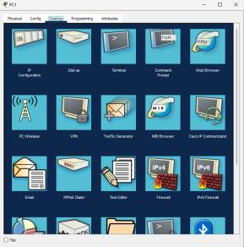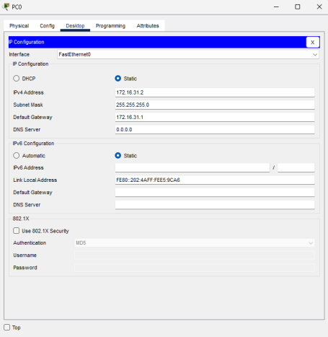

**default gateway**

**Click on desktop on PC’s,**

**Laptops, SmartPhones, and**

**Tabletes**

* 1. **The Routers Configuration**

**R0:**

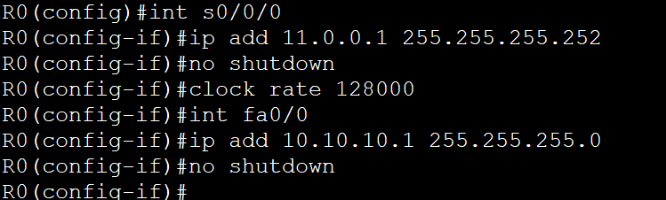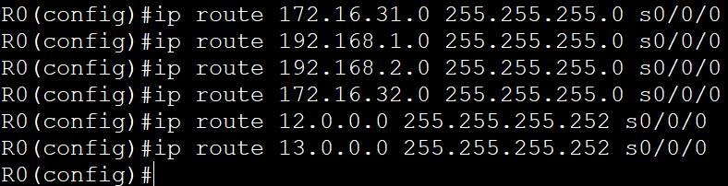

* 1. **The Routers Configuration**

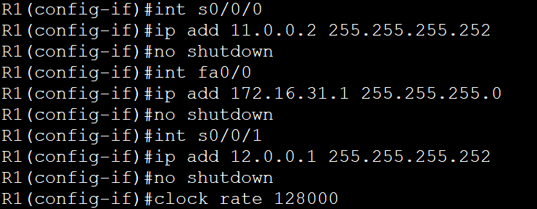**R1:**

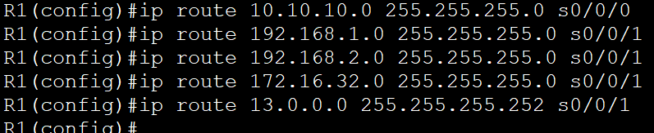

**6.1 Server Configuration**

**Make DHCP Server:**

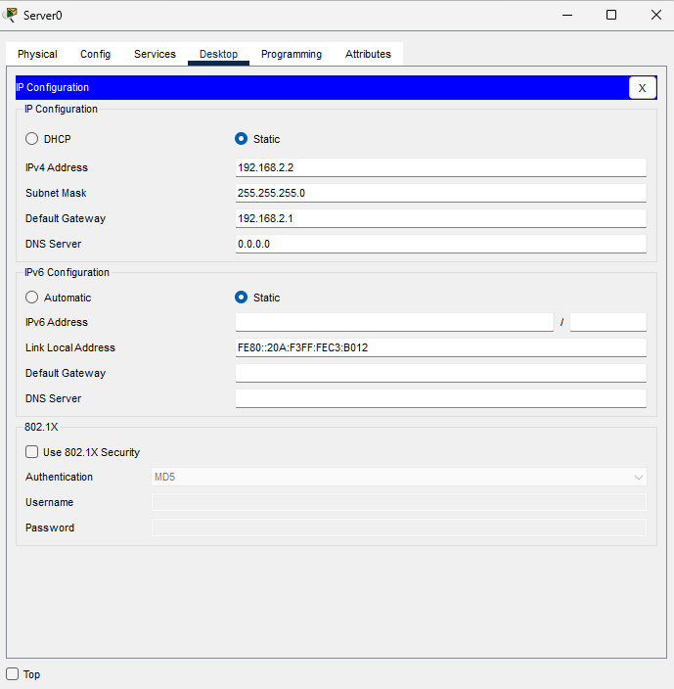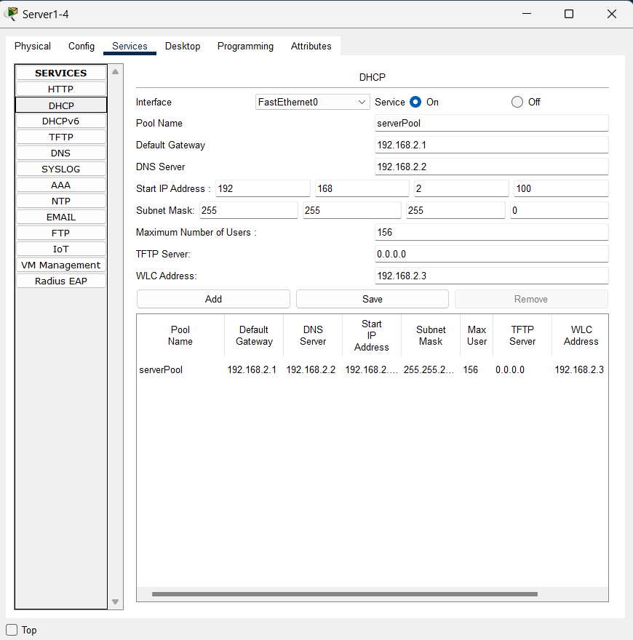





* 1. **WLANC Configuration**

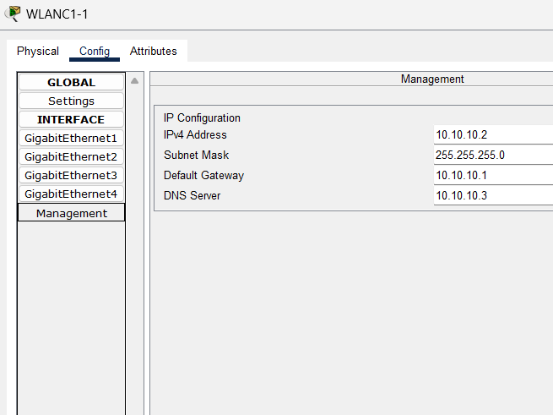

* 1. **WLANC Configuration**

**Access to WLANC:**

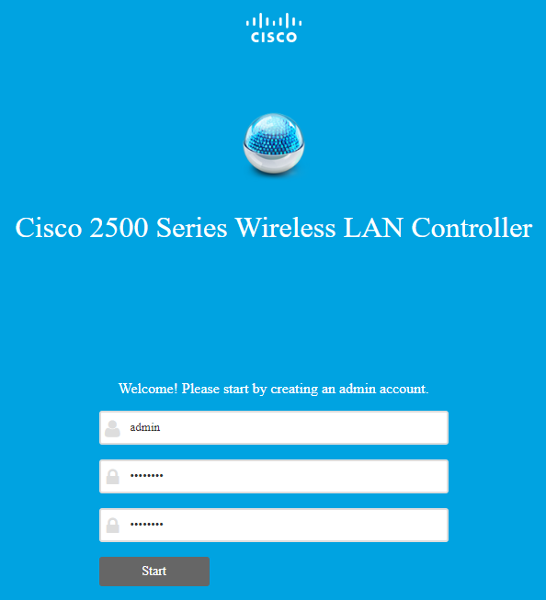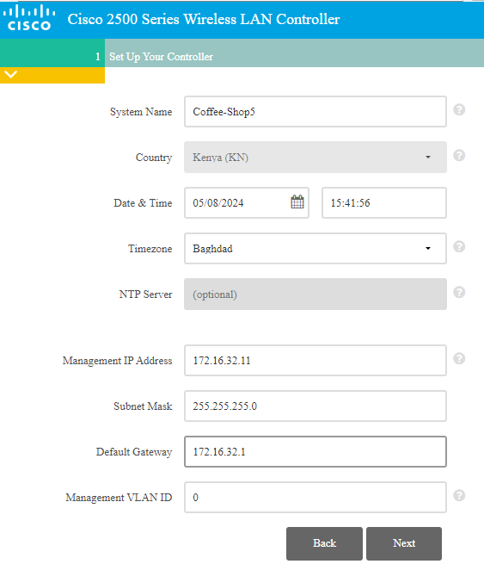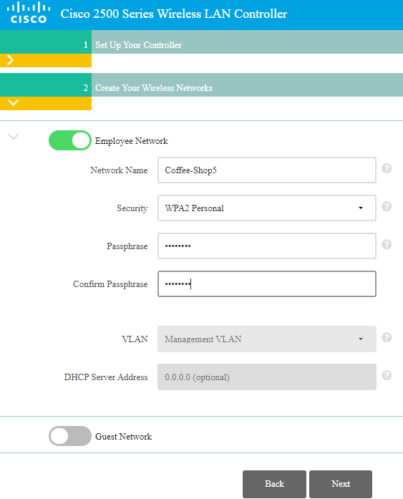

* 1. **WLANC Configuration**

**Check the Configuration of WLAN and AP:**

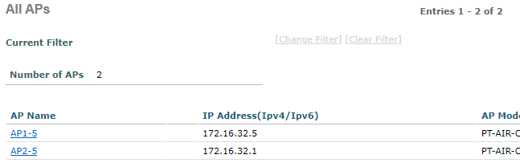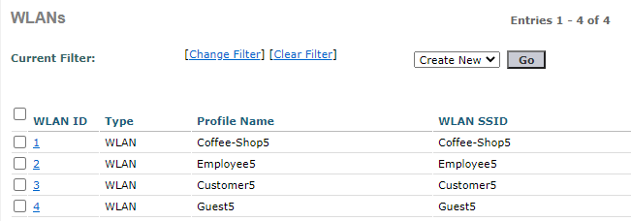

* 1. **WLANC Configuration**

**Add new WLAN:**

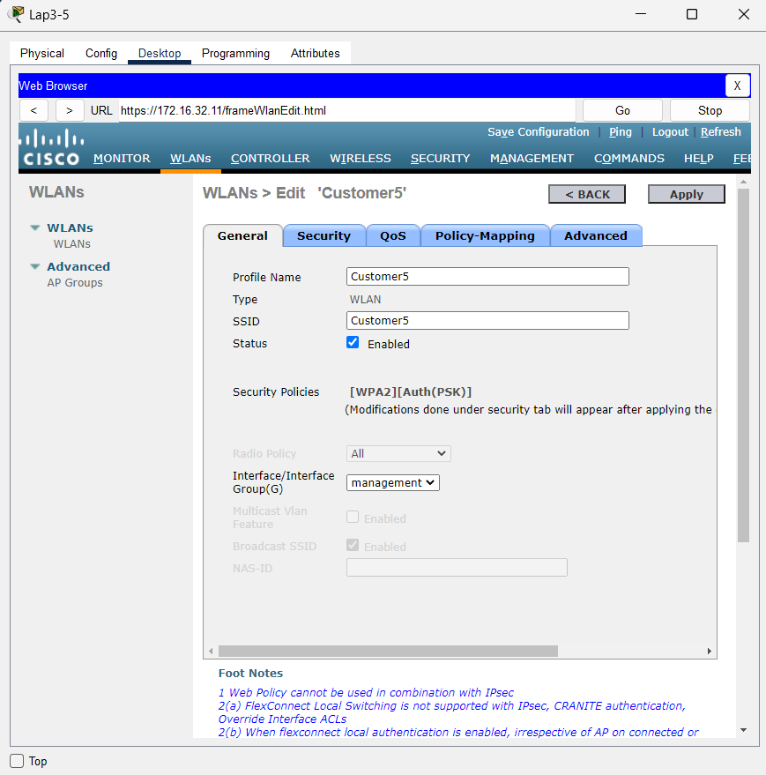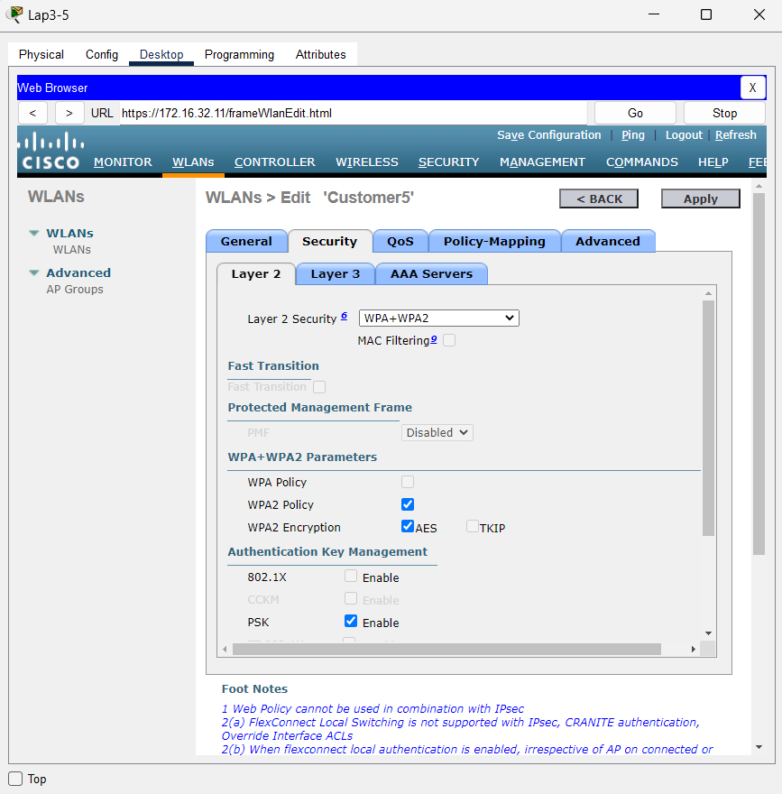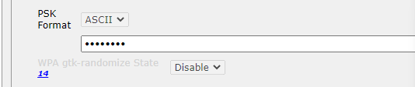

**8.1 Configuration Wireless**

**Connecting PC’s to the access point: Connecting printers to the access point:**

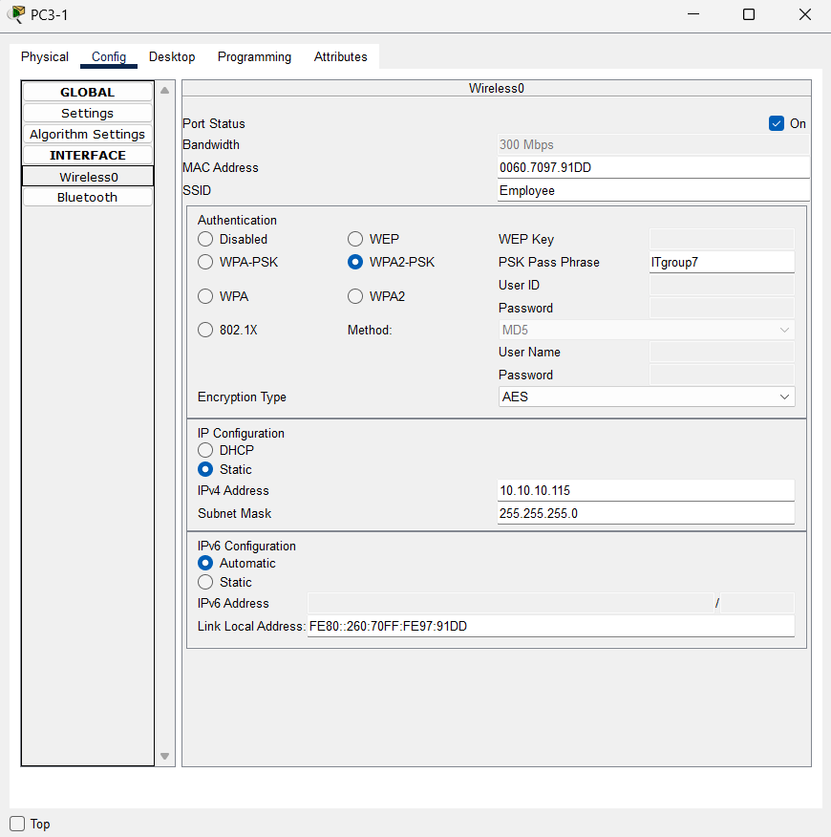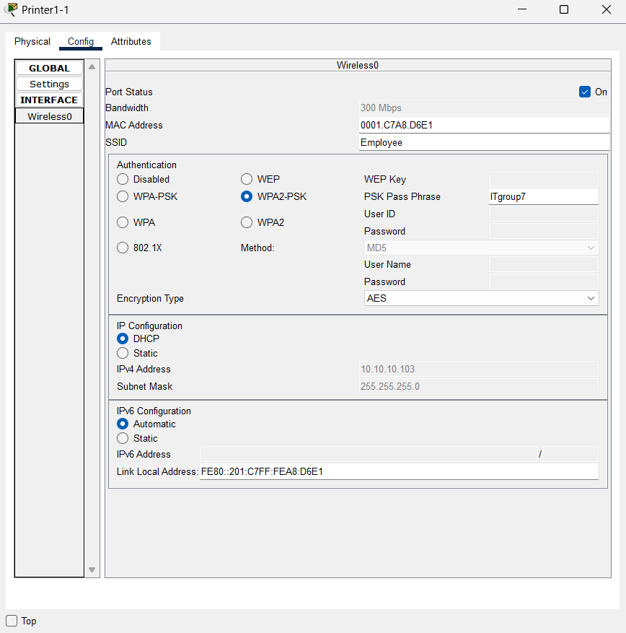

* 1. **VLAN Configuration**

**Configuration Vlan between Switches:**

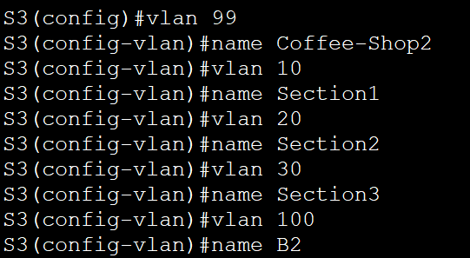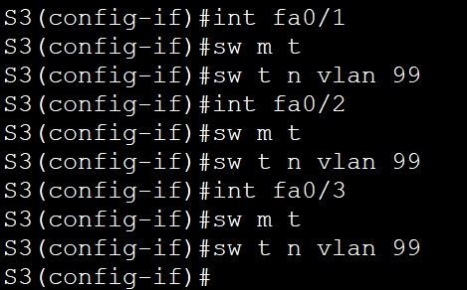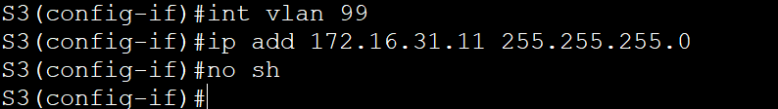

* 1. **VLAN Configuration**

**Configuration Vlan between Switch and PC’s:**

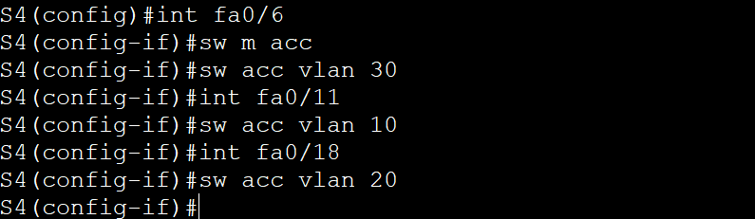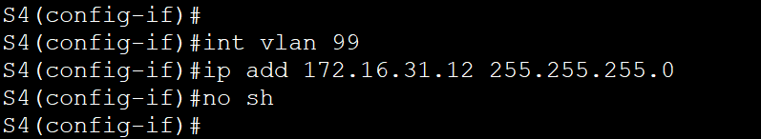

* 1. **OSPF and Rip Configuration**

**Configuration Routers using Rip:**

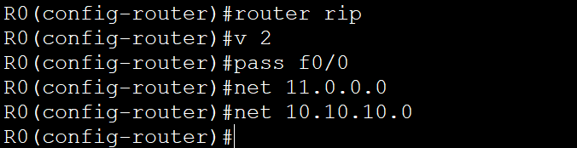

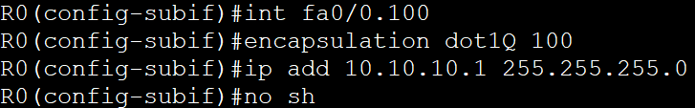

* 1. **OSPF and Rip Configuration**

**Configuration Routers using OSPF:**

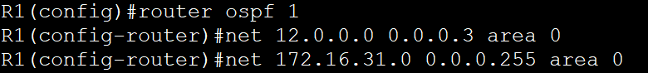

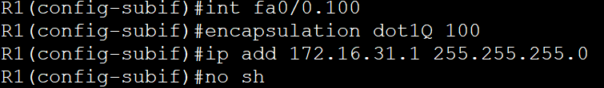

* 1. **OSPF and Rip Configuration**

**Configuration Routers using both OSPF and Rip:**

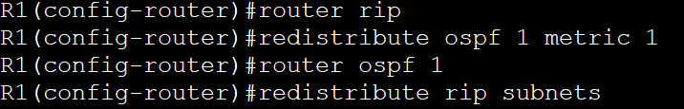



# Verification

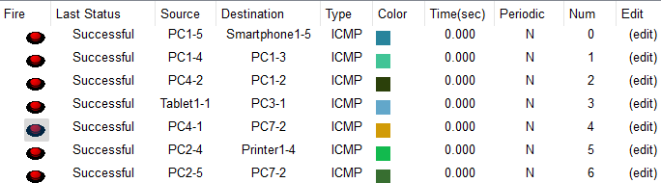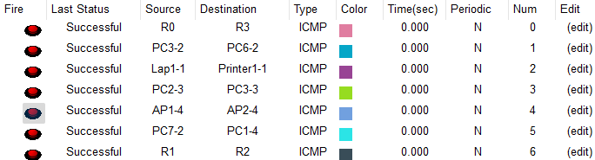



**Branch-3** ➔

e.g.



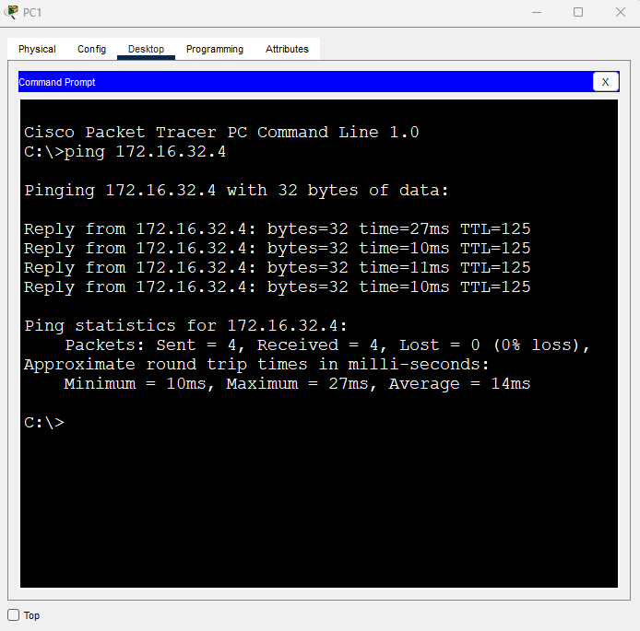**Ping from PC1-5 to**



**Laptop1-5**

# Verification

* 1. **Verification**





**Branch-1** ➔

**Branch-2** ➔

e.g.

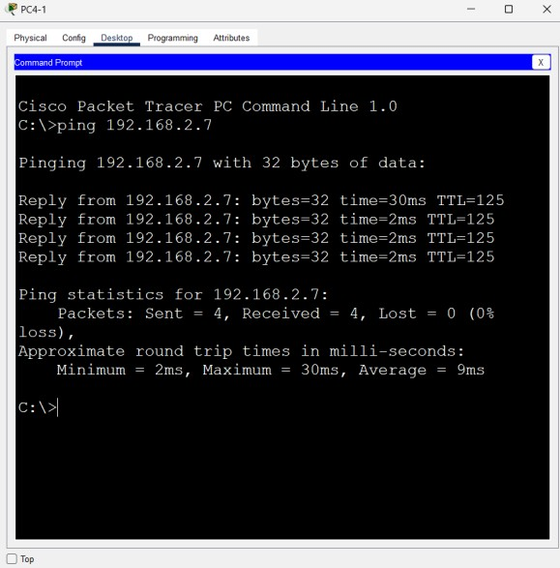**Ping from PC4-1 to**

**Laptop1-4**

**Ping from Manager in Branch1 to Manager in Branch2**



**12.0 CONCLUSION**

The Coffee Shop Network project has successfully achieved its objectives, utilizing the Cisco Packet Tracer as the primary tool. The project aimed to establish an interconnected network among multiple coffee shop branches, enhancing communication, facilitating transactions, and optimizing overall operations. The project's outcomes align with its objectives, showcasing the effectiveness of the implemented network infrastructure. The network deployment has enabled the coffee shop to quickly handle many customers. the seamless connection between branches has fostered improved communication channels, allowing for the swift sharing of information and resources.



#### Case study: Amazon AWS

**Concept of cloud computing:**

Cloud computing provides several diverse online services that meet the client’s needs without the need to purchase devices, cyber security staff, and pay high amounts. They provide services such as: databases, servers, software, and networking. Amazon provides various services in the field of cloud computing, as it is considered the most comprehensive, as it has very high security, a strong infrastructure, 17 years of experience, and serves millions of customers. It is used by many customers, which reduces its cost and increases flexibility, and it varies with more than 200 services. It is considered the most secure because its basic structure was initially designed to meet the security needs of government institutions and international banks. They also have an amazing technical support team to solve problems. Choosing cloud computing for Amazon helps large and small companies because it provides you with your service needs and ensures their safety at a reasonable price. It helps avoid contracting with multiple employees because it provides you with services without needing your own staff and saves space and purchasing devices because everything is virtual on the Internet.



#### Cloud computing models and usage areas:

Amazon offers many models and areas of use. We will mention three examples of what Amazon

can offer.

#### Infrastructure as a Service (IaaS) Model:

Provides a virtual computing service over the Internet. A business model that provides infrastructure for information technology in exchange for payment that allows you to use the services you need via the Internet. The reason for its importance is that it helps in expansion and reducing costs and helps in eliminating the need to buy local devices and maintain them. One example is Amazon. They said that during the holiday season, application users increase three-fold, and this requires the purchase of additional server devices to overcome this problem.

Amazon provides many secure centers with several devices and many devices. In exchange for payment, the customer can receive services via the Internet. Amazon offers several features, including speed, performance, reliability, backup and recovery, and a competitive price. They help you improve operational efficiency. They work on the principle of virtualization, allowing you to determine the type of infrastructure you need. This service can be used via Amazon Simple Storage Service.

#### Platform as a Service (PaaS) Model:

A platform targeting developers to create and develop websites and to create, publish and manage applications without the complexities of infrastructure management. It includes solutions and tools that help programmers. Amazon provides this service using Elastic Beanstalk. You can publish and manage applications via AWS Cloud without the need to look at the infrastructure. You only must download your applications. Elastic Beanstalk supports applications developed in Go, Java, .NET, Node.js, PHP, Python, and Ruby.

#### Software as a Service (SaaS) Model:

It provides software applications fully managed by Amazon through the Internet. Customers can use the applications without the need for installation or maintenance. They only must subscribe. Amazon provides this service through Amazon WorkMail, an email service that provides security and support for customers on desktop and mobile devices. To access email and contacts, you need several applications, but Amazon WorkMail provides them without the need for several applications.

#### How Does Cloud Computing Work?

Cloud computing operates by utilizing a network of remote servers hosted on the internet to store, handle, and process data, rather than relying on a local server or personal computer. This enables users to access resources and services whenever needed, as long as they have an internet connection. The pay-as-you-go model of cloud computing ensures that users only pay for the resources they utilize, making it a cost-effective solution for businesses of all sizes. AWS provides a comprehensive range of cloud computing services, such as computing power, storage, databases, machine learning, and more. These services can be easily accessed through a user- friendly web interface or API.

#### What cloud-computing services providers are available?

Cloud computing services come in various forms, catering to different needs and preferences. Some of the prominent cloud computing service providers include:

##### Amazon Web Services (AWS):

Amazon Web Services (AWS) stands as a frontrunner in the cloud services, offering an extensive suite of services spanning computing power, storage, databases, machine learning, analytics, and more. With a global presence and a robust infrastructure, AWS caters to businesses of all sizes, from startups to enterprises, enabling them to innovate and scale efficiently.

##### Microsoft Azure:

Microsoft Azure is a comprehensive cloud platform that provides a wide array of services, including computing, analytics, storage, networking, and artificial intelligence. Leveraging Microsoft's expertise and global reach, Azure empowers organizations to build, deploy, and manage applications with flexibility and scalability, while also integrating seamlessly with other Microsoft products and services.

##### Google Cloud Platform (GCP):

Google Cloud Platform (GCP) offers a suite of cloud computing services focused on computing, storage, machine learning, data analytics, and application development. With Google's expertise in data management and machine learning, GCP provides innovative solutions to help businesses drive insights, optimize operations, and accelerate digital transformation initiatives.

##### IBM Cloud:

IBM Cloud provides a comprehensive range of cloud services, including infrastructure as a service (IaaS), platform as a service (PaaS), software as a service (SaaS), and hybrid cloud solutions. With a focus on enterprise-grade security, AI-driven capabilities, and industry-specific solutions, IBM Cloud caters to the unique needs of businesses across various sectors, from healthcare to finance to manufacturing.

##### Oracle Cloud:

Oracle Cloud offers a robust suite of cloud services, encompassing computing, storage, databases, applications, and industry-specific solutions. With a focus on performance, reliability, and security, Oracle Cloud enables organizations to modernize their IT infrastructure, innovate with emerging technologies, and drive business agility in a highly competitive market landscape.

These are just a few examples of leading cloud computing service providers, each offering unique capabilities and solutions to address the evolving needs of businesses in today's digital age. By partnering with the right cloud provider, organizations can leverage the power of cloud computing to drive innovation, accelerate growth, and stay ahead of the competition.



#### How chosen cloud is different from other cloud service providers?

AWS stands out from other cloud service providers due to its extensive global infrastructure. With data centers located in various regions worldwide, AWS offers unparalleled reliability and minimal latency, ensuring that users can swiftly and securely access their applications and data from anywhere. Moreover, AWS boasts a vast ecosystem of services and tools, empowering users to develop, deploy, and manage virtually any kind of application or workload. The commitment of AWS to innovation and customer satisfaction further distinguishes it from its competitors, as it consistently introduces new features and services to cater to the ever-changing needs of its customers.

**References:**

* <https://docs.aws.amazon.com/pdfs/AmazonS3/latest/userguide/s3-userguide.pdf>
* [https://aws.amazon.com/ar/what-is-aws/?sc_icampaign=aware_what_is_aws_default&sc_ichannel=ha&sc_icontent=awssm- evergreen_pac_default&sc_iplace=hero&trk=ha_awssm-evergreen_pac_default](https://aws.amazon.com/ar/what-is-aws/?sc_icampaign=aware_what_is_aws_default&sc_ichannel=ha&sc_icontent=awssm-evergreen_pac_default&sc_iplace=hero&trk=ha_awssm-evergreen_pac_default)
* <https://aws.amazon.com/ar/what-is/iaas/>
* <https://docs.aws.amazon.com/elasticbeanst>
* <https://docs.aws.amazon.com/pdfs/workmail/latest/userguide/workmail-ug.pdf>
* <https://aws.amazon.com/what-is-aws/>
* <https://aws.amazon.com/what-is-aws/>
* https://adaptis.io/insights-by-adaptis/cloud-platforms-services
* https://greenappleit.co.za/leading-cloud-providers/
* https://weareprimegroup.com/insights/the-importance-of-cloud-computing-providers/
* https://apprecode.com/blog/navigating-the-cloud-a-detailed-analysis-of-the-top-10-cloud-service-providers
* https://[www.digitalocean.com/resources/article/google-cloud-alternatives](http://www.digitalocean.com/resources/article/google-cloud-alternatives)





**THANKS!**

Does anyone have any question?